Name: Iqra
Roll No. 221
Artificial Intelligence (Lab)
Task NO. 1
Question #1:

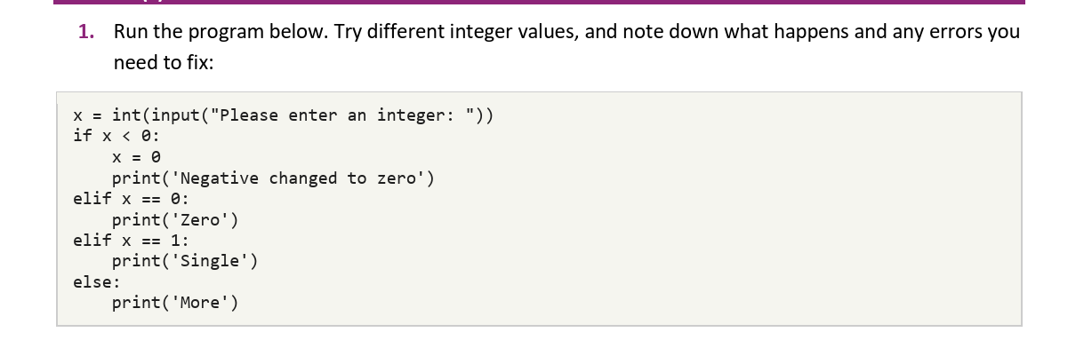
Ans:
There’s no error in this program. If we try different integer values no change occurs but if we use non integer values value error occurs because it is written in the first line of the code that the value must be integer
x = int(input(“Please enter an integer:”))
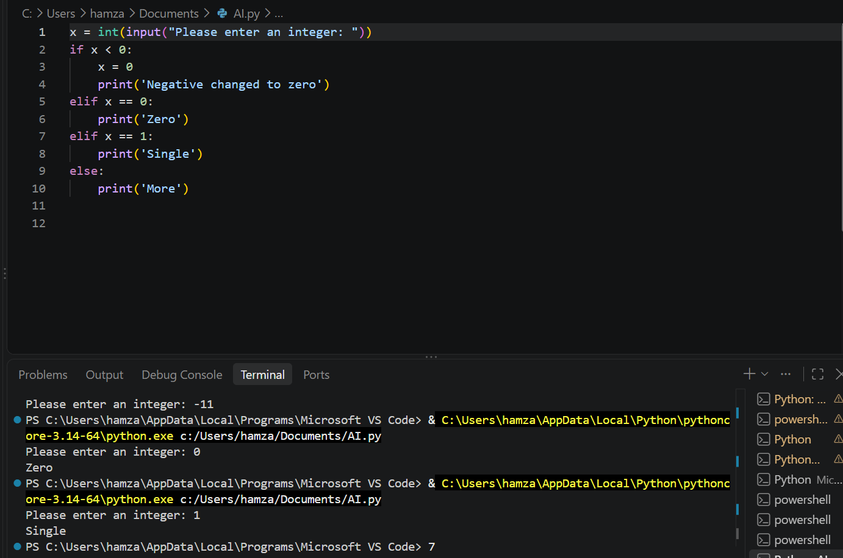
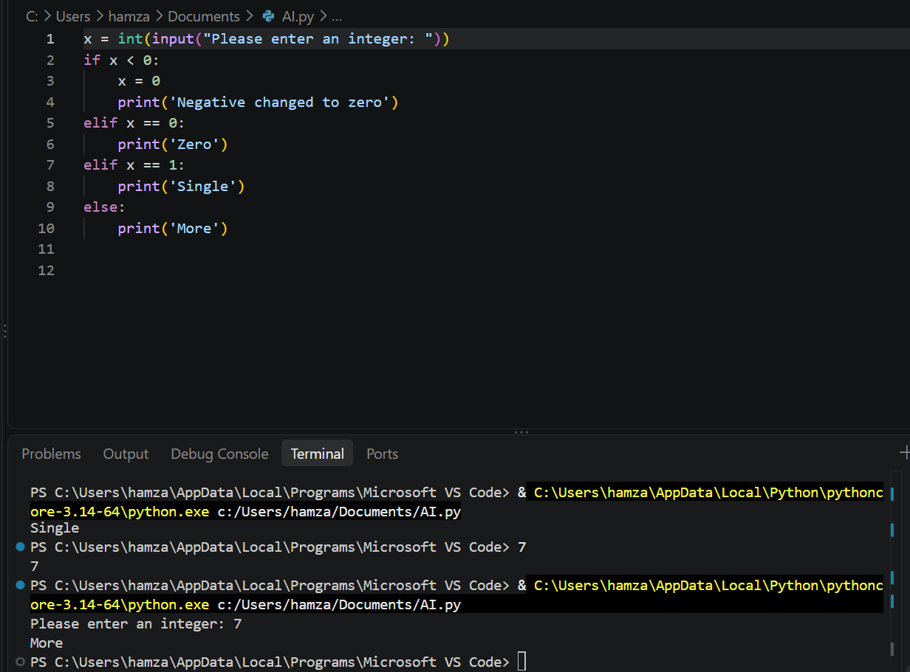

Question #2:
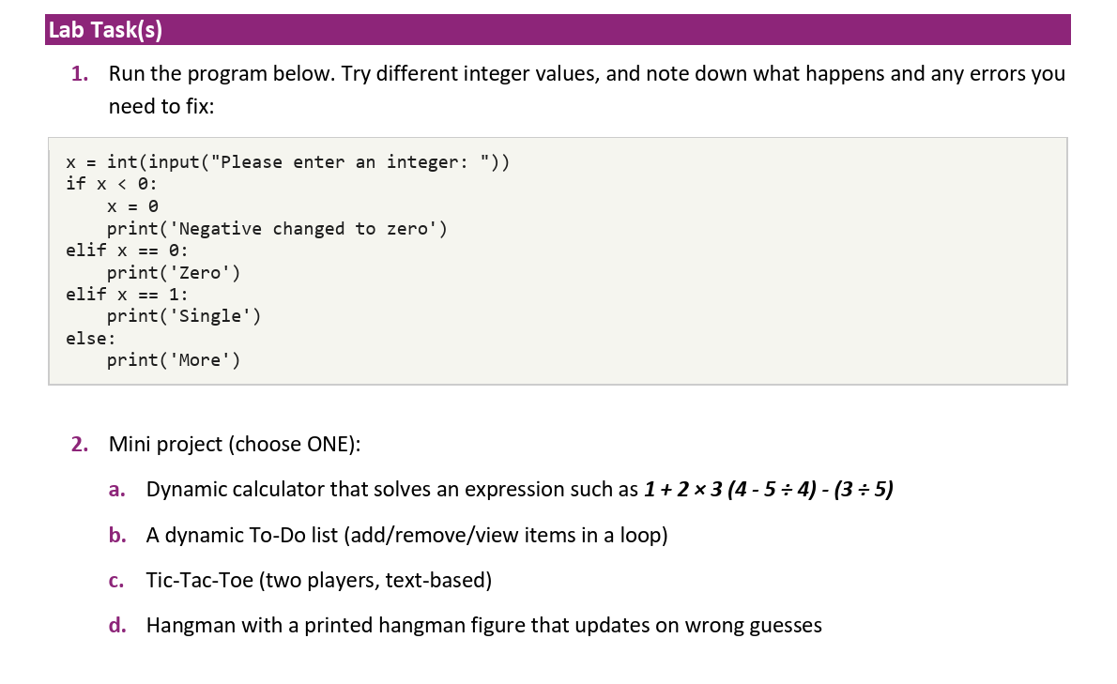
Ans:

This document explains all the steps I used to make hangman game with the hangman figure that updates in wrong guesses.

1. Importing random

import random
We use the random module so that the computer can choose a word randomly from a list.

2. Creating a list of words

The list contains the words that the computer can choose from. You can add more words to make the game more interesting.

3. Choosing a secret word

word = random.choice(words)

This selects one word from the list and stores it in the variable word. The player does not see this word at the beginning.

4. Hiding the word
guessed_word = ["_"] * len(word)

This creates underscores for every letter in the secret word. For example, if the word is 'apple', the player initially sees:
_ _ _ _ _

5. Keeping track of wrong guesses
wrong_choice = 0

The variable wrong_choice starts at zero. Every time the player enters a wrong letter, we increase it by 1.

6. Starting the game loop
while wrong_choice < 6 and "_" in guessed_word:

The while loop keeps the game running while the player has fewer than 6 wrong guesses and there are still underscores in the hidden word.

7. Printing the current hangman figure

print(hangman[wrong_choice])

Python uses the value of wrong_choice as the list index. When wrong_choice is 0, the first drawing is shown. After a wrong guess, wrong_choice becomes 1, so the next drawing is shown.

8. Showing the hidden word
print("Word:", " ".join(guessed_word))

join() puts spaces between the letters and underscores so the word is easier to read.

9. Asking the player for a letter
guess = input("Enter a letter: ").lower()
input() allows the player to type a guess. lower() changes an uppercase letter such as A into lowercase a, so the guesses match the lowercase words in our list.

10. Checking a correct guess
if guess in word:
print("Correct guess :)")
for i in range(len(word)):
if word[i] == guess:
guessed_word[i] = guess

If the guessed letter exists in the secret word, the for loop checks every position. Whenever it finds the guessed letter, the underscore at that position is replaced by the letter.
Example: if the word is 'apple' and the player guesses 'p':
_ p p _ _

11. Handling a wrong guess
else:
wrong_choice += 1
print("Wrong guess :(")

If the letter is not in the secret word, wrong_choice increases by 1. The next hangman drawing will then be displayed.

12. Checking whether the player won or lost
if "_" not in guessed_word:
print("You won ^ ^")
print("The word was:", word)
else:
print("You lost> <")
print("The word was:", word)

If there are no underscores left, the player has guessed every letter and wins. Otherwise, the game ended because the maximum number of wrong guesses was reached.

13. Main Python Concepts Used
Concept | Purpose
import | Used to bring the random module into the program.
list | Stores the possible words and the hangman drawings.
random.choice() | Chooses a random word.
len() | Finds the number of characters in the word.
input() | Gets the player's guess.
if / elif / else | Makes decisions based on the player's guess.
while loop | Keeps the game running.
for loop | Checks every position in the secret word.
in | Checks whether a letter exists in the word.
range() | Creates the positions used by the for loop.
continue | Skips the rest of the current loop and starts the next round.

